Roughing

Introduction
There are two strategies for roughing a 3D component Model. These are Z Level and Plunge roughing. Z level roughing provides a choice of 2D material removal methods, which progressively machine the area (Slice), up to the component contour, down a sequence of user-defined Z Heights. Plunge roughing clears material from a part by a series of drilling operations.

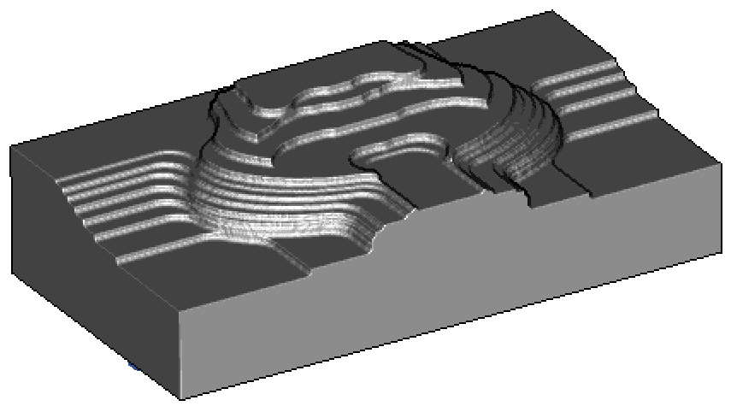

In Z Level roughing, sometimes known as Waterline Roughing, the cutter steps down to a specified Z Height and fully clears an area (Slice) before stepping down to the next Z Height to repeat the process.

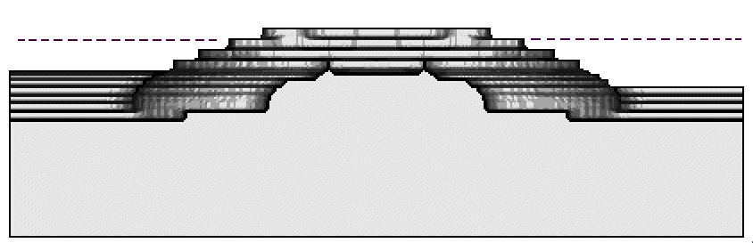

For some components it is desirable to use a secondary area clearance strategy. This is done using the Multiple Rough option where a series of tools is specified each reducing in size from the previous. This will locally remove pockets of excess material inaccessible to the previous tool. This will reduce the degree of tool overload and provide a more consistent material removal rate for any subsequent Finishing operations.

If the original material is in the form of a casting or fabrication then it may not be necessary to apply any Area Clearance machining but rather go directly for a semi-Finishing strategy.

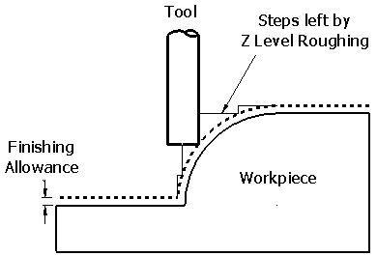
Toolpaths
Suitable values are required to control the accuracy and amount of excess material to be left on a component by a toolpath. The parameters used for this purpose are preset and are called Finish Allowance and Tolerance.

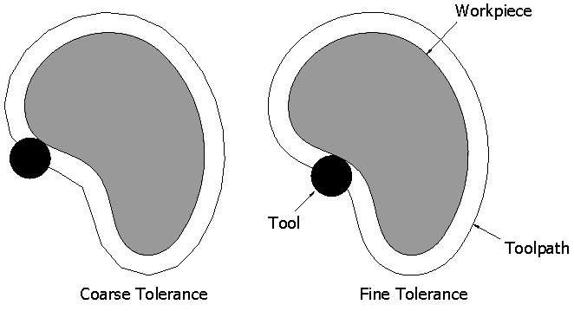
Finish Allowance is the amount of extra material specified to remain on the work-piece after machining. It should be noted that this will be the minimum amount of material left on.
Tolerance controls the accuracy to which the toolpath follows the shape of the work-piece. For roughing a Coarse tolerance can be used but for finishing a Fine tolerance must be used.
The illustration shows an individual roughing Z level viewed from above.

Note where the Finish Allowance value is greater than 0 it should always be more than the tolerance value

Zig-zag Roughing Example

In this example a part will be roughed using a Zig-zag strategy. Zig-zag removes the material from the model using a series of parallel passes at each level on the part. First a model will be imported and positioned using the stock wizard.

- Open a new millimeter milling document.
- Press Finish on the Dimensions form.
- Import the model speaker_core.igs.
- On the import form click Use the wizard to establish the initial setup location and stock size.
- Click Next until you reach the Pick Initial Setup X Orientation page.
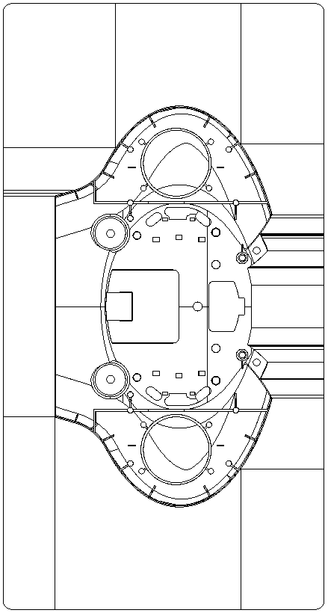

It can be seen that the long axis of the imported part is aligned with the Y axis. We need to turn the part around so that it is aligned with the X axis.

- Click on the Rotate X direction 90 degrees around Z axis button
- Click Next until you reach the Stock Dimensions page.
- Check Compute stock size from the size of the part and click next.
- Select the required setup location (stock center) by clicking on the hand icon indicated
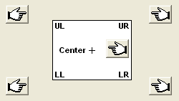

- Click Finish.
- Select an Isometric view.

The part is now aligned correctly and the stock has been sized to the part.
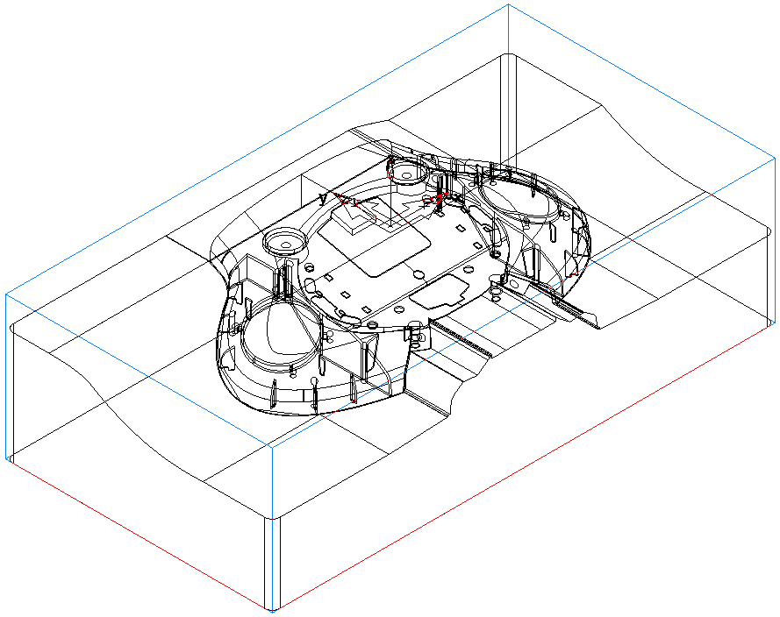

Now that the part has been imported and the set up completed we are ready to begin the roughing operation.

- Click on Features in the Step view.
- Check Surface Milling and press Next.
- Box select all of the surfaces and then press the Add from selected items button then click next.
- On the New strategy form check Choose a single operation.
- Click Next.
- Check Z Level in the Roughing Strategies part of the form.
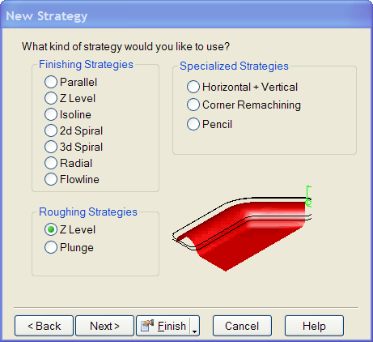

- Click Next.

- Fill in the Strategy form exactly as below and then press Next twice.

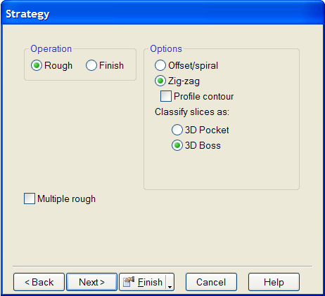

The tool selected from the crib is a 12mm diameter end mill. As this is a large part it would be better to use a 50mm diameter bull nosed cutter with a 6mm tip radius.

- On the New feature – tool search form change the Tool group to Bullnose endmill.
- Click on the New tool button at the bottom of the form.
- Fill in the form exactly as shown below.

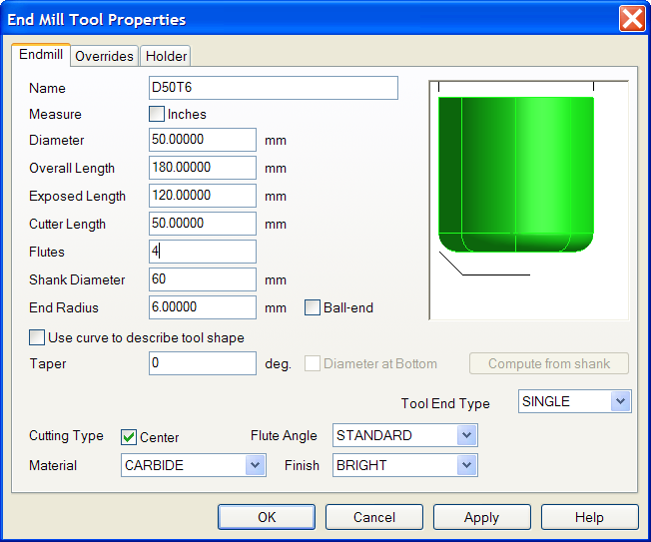

- Press Apply and then OK.
- At the prompt Set new tool as override? Press Yes.
- Press Finish.

- Run a 3D simulation.

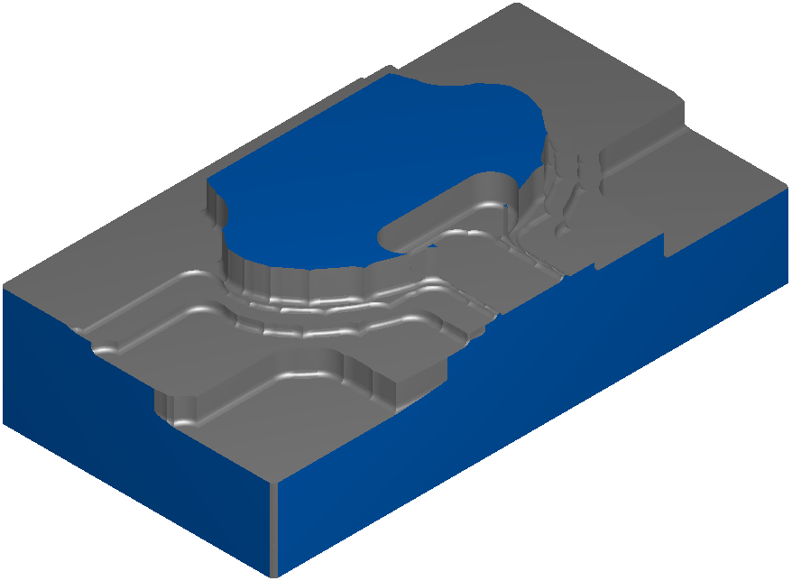

Note how the roughing operation has left cusps where the tool is changing direction at the end of every other pass. We will now modify the feature to rectify this.

- Edit the feature (double click on srf_mill 1 in the Part view).
- Click on Z level in the tree view.
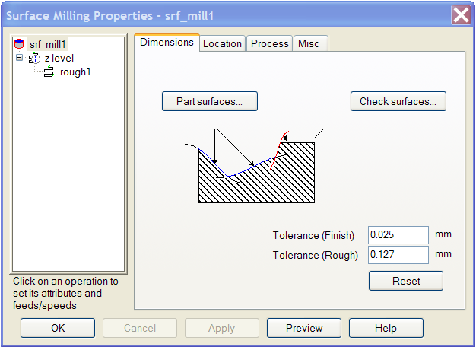

- Select the Strategy tab and check Profile contour, then press OK.
- Run a 3D simulation.

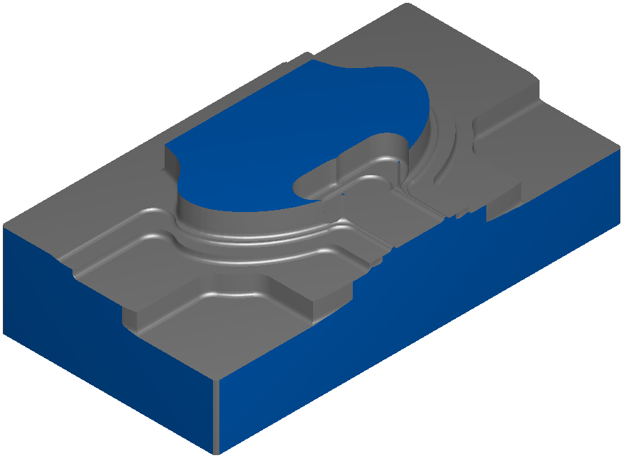

The tool is now profiling the part after roughing each Z level. This will increase the cutting time but will give a more constant tool loading in subsequent operations. We will now take a look at some of the other options that are available to control the creation of the toolpath.

- Edit the feature.
- Click on rough 1 in the tree view.
- Select the Milling tab.
- Click on Finish Allowance.
- In the New value box at the bottom of the form enter 0.5 and press Set.

This has changed the minimum amount of material left on the part to be 0.5mm. It should be noted that the actual amount of material left on the job will depend upon the Finish Allowance, the Z increment (the step down between roughing levels) and the shape of the surfaces being roughed. We will now change the stepover between passes and the Z increment.

- Click on Rough pass stepover % and set it to 75%.
- Click on Z increment and set it to 6mm.

- Run a 3D simulation.

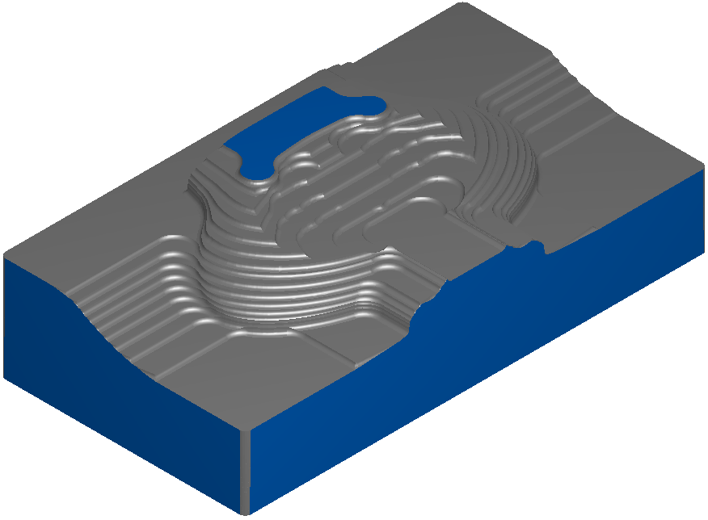

The reduced Z increment has removed much more material from the part giving a more even amount of remaining stock for subsequent operations. This will also increase the machining time which is partially compensated for by the increased stepover.

We will now look at Offset/spiral roughing. In this method the passes follow the profiles of the part & stock rather than being parallel to an axis.

- Edit the feature.
- Click srf_mill 1 in the tree view.
- Select the Process tab and uncheck the operation z level.
- Click on Apply and then OK.

This suppresses the feature so that it will not appear in any simulations.

- Click on Features in the Step view.
- Check Surface Milling and press Next.
- Box select all of the surfaces and then press the Add from selected items button then click next.
- On the New strategy form check Choose a single operation.
- Click Next.
- Check Z Level in the Roughing Strategies part of the form.
- Press Next.
- Check Offset/spiral on the Strategy form then Next.
- On the New feature – tool search form change the Tool group to Bullnose endmill.
- From the list select the tool D50T6 and press Finish.
- Edit the feature.
- Click on rough 1 in the tree view.
- Select the Milling tab and set the Finish Allowance to 0.5mm, Rough pass stepover % to 75% and the Z increment to 6mm as before.
- Run a Centerline simulation.
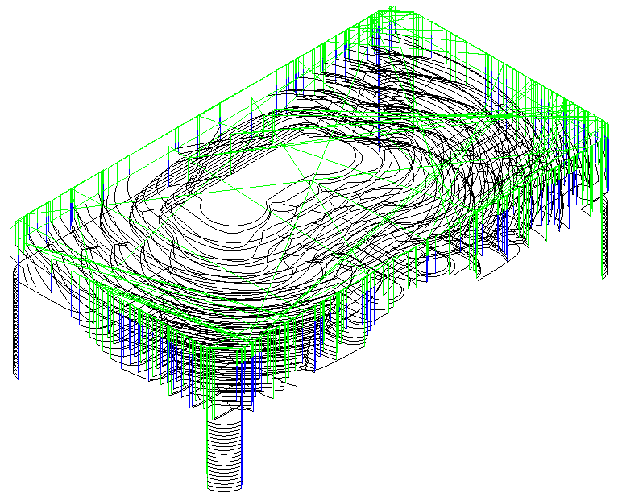

The tool now profiles smoothly around the part with fewer sudden changes in direction than the Zig-zag strategy. An Offset/Spiral toolpath is generally shorter than a Zig-zag toolpath with the same settings.

Rest Roughing

When roughing a part it is desirable to use as large a tool as possible to minimize machining time. The use of a large cutter may mean that some smaller pockets are not cut in the roughing process. FeatureMILL3D has the capability to automatically remachine any areas that are not cut in the first roughing process using a second smaller cutter.

- Open a new millimeter milling document.
- Press Finish on the Dimensions form.
- Import the model Rest Mill.igs.
- On the import form click Use the wizard to establish the initial setup location and stock size.
- Click Next four times.
- Click Finish.
- Select an Isometric view.

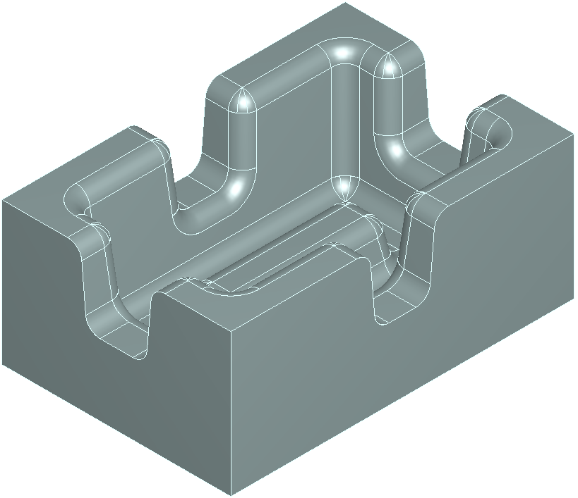

This part is to be roughed with a 25mm diameter endmill, this will not cut the slots or the area around the boss in the center of the pocket. Material will also be left in the corners of the pocket as the fillet radius is smaller than the cutter radius. An 8mm diameter end mill will then be used to remove the remaining rough stock.

- Click on Features in the Step view.
- Check Surface Milling and press Next.
- Box select all of the surfaces and then press the Add from selected items button then click next.
- On the New strategy form check Choose a single operation.
- Click Next.
- Check Z Level in the Roughing Strategies part of the form.
- Press Next.
- Fill in the form exactly as shown below. Note that the tool diameters 25 and 8 must be separated by a comma.
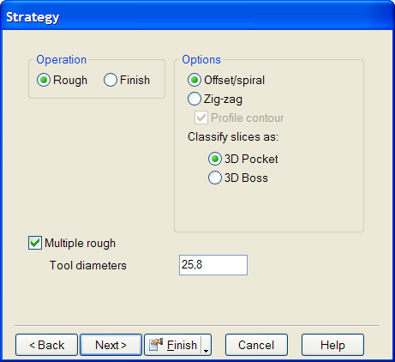

- Click Finish.
- Edit the Feature.
- Click on rough 1 in the tree view.
- Click on the Milling tab.
- Set the Z increment to 5.
- Click Apply.
- Click on rough 2 in the tree view.
- Click on the Milling tab.
- Set the Z increment to 2.5.
- Click Apply and then OK.
- Click on Manufacturing on the main menu and select Post Process.

- Set the Tool change location to be at Z 50.
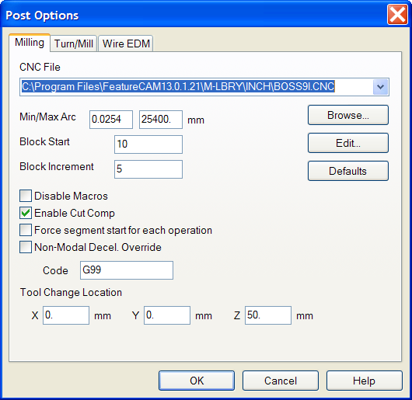

- Run a Centerline simulation.
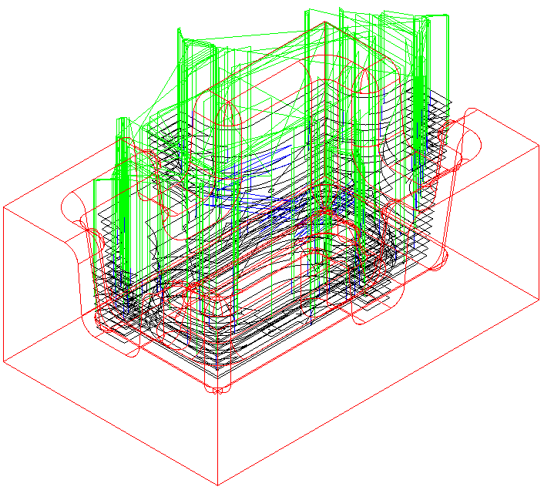

Note how the main area is cleared by the 25mm diameter endmill first, the 8mm diameter cutter then just picks out the areas that could not be reached by the larger cutter.

- Run a 3D Simulation to better visualise the process.

Limiting tool overload

When roughing a part which has narrow slots, when entering a sharp corner or on the first pass in a pocket it is desirable to avoid overloading the tool. It is possible to do this by using trochoidal machining. This strategy detects when tool overload is likely and changes from normal machining to a toolpath which enters the overload area in a series of loops as shown below. This greatly reduces the tool loading and allows the toolpath to be run at a higher feedrate without damaging the tool.
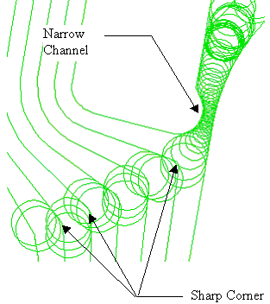

- Open a new millimeter milling document.
- Press Finish on the Dimensions form.
- Import the model Lever Die.igs.
- On the import form click Use the wizard to establish the initial setup location and stock size.
- Click Finish.
- Select an Isometric view.
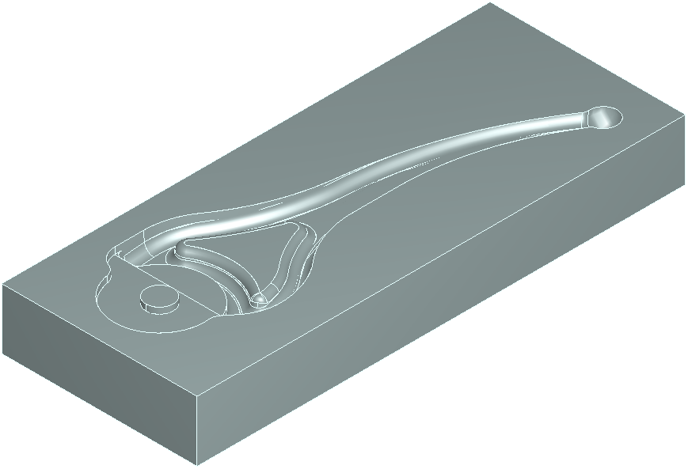

This model contains several narrow areas which will require machining with a small tool. To avoid the risk of tool breakage the part will be rest roughed with a 5mm diameter endmill and then a 3mm ball nose cutter using trochoidal milling.

- Click on Features in the Step view.
- Check Surface Milling and press Next.
- Box select all of the surfaces and then press the Add from selected items button then click next.
- On the New strategy form check Choose a single operation.
- Click Next.
- Check Z Level in the Roughing Strategies part of the form.
- Press Next.
- Fill in the form exactly as shown below. Note that the tool diameters 5 and 3 must be separated by a comma.
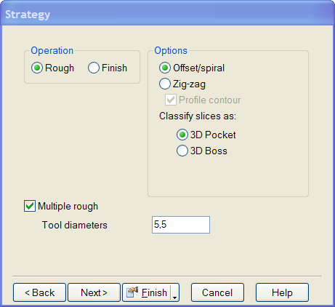

- Edit the feature.
- Click on srf_mill 1 in the tree view.
- Change the roughing tolerance to 0.1mm.
- Click on rough 1 in the tree view
- Select the Milling tab.
- Set the Finishing allowance to 0.25mm.
- Press Apply.
- Click on rough 2 in the tree view
- Select the Milling tab.
- Set the Finishing allowance to 0.25mm.
- Check the Trochoidal cut option.
- Set Avoid overload (%stepover) to 25%
- Press Apply.
- Click on the Tools tab.

- Select a 3mm Ball endmill.
- Press Apply and then OK.
- Answer Yes to the prompt – Set new tool as override?
- Press Apply and then OK.
- Run a Centerline simulation.

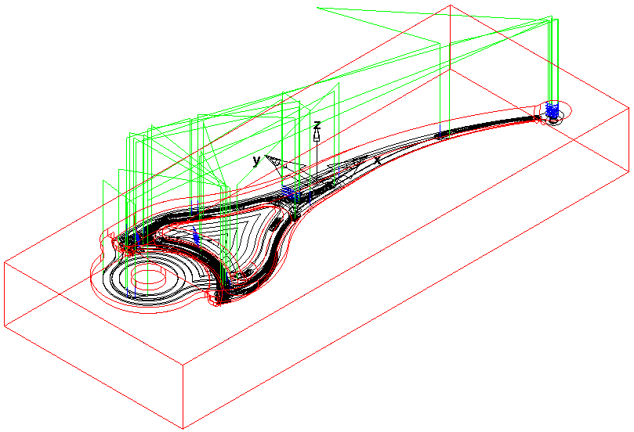
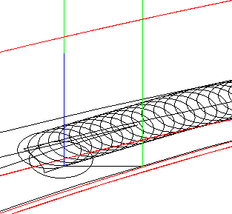

Zoom on the neck area of the lever to see how the trochoidal toolpath is generated in areas where tool overload could occur.

- Run a 3D Simulation to see the trochoidal milling in action.

Machining Flats
The area clearance strategies in FeatureMILL3D have an option that allows the user to control the way in which flat areas of the model are rough machined.

- Open a new millimeter milling document.
- Press Finish on the Dimensions form.
- Import the model Flats.igs.
- On the import form click Use the wizard to establish the initial setup location and stock size.
- Click Finish.
- Select an Isometric view.
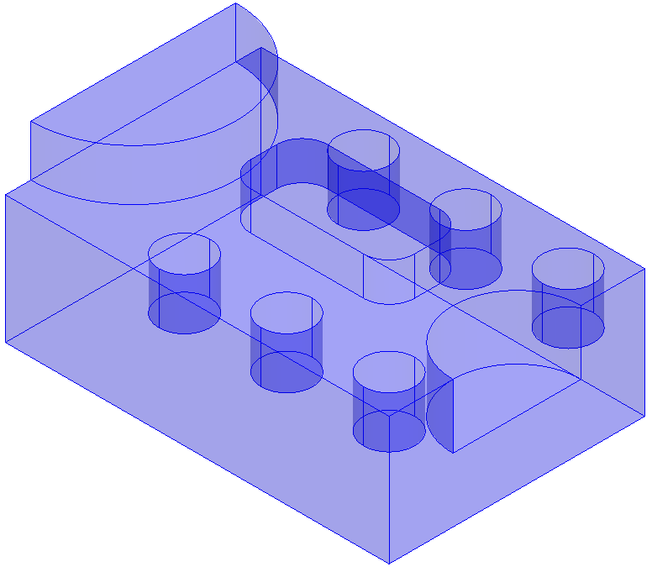

This model contains several horizontal flat areas. If these areas are not machined there may be an excess of stock remaining for semi-finishing process to work well. We will now look at how to control the machining of flats.

- Click on Features in the Step view.
- Check Surface Milling and press Next.
- Box select all of the surfaces and then press the Add from selected items button then click next.
- On the New strategy form check Choose a single operation.
- Click Next.
- Check Z Level in the Roughing Strategies part of the form.
- Press Finish.
- Edit the feature.
- Click on rough 1 in the tree view.
- Select the Milling tab.
- Fill in the form exactly as shown below, setting Flat surface support to Off and setting the Z increment to 12.
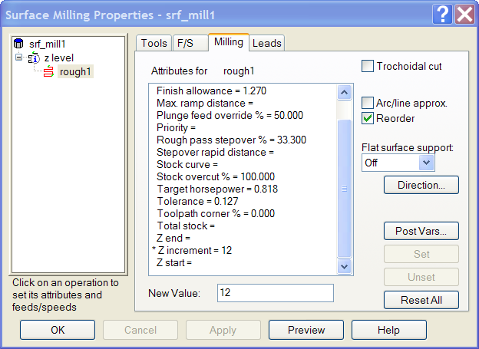

- Press Apply and then OK.
- Click Manufacturing on the main menu.
- Choose Post Process.
- Set the Tool change location Z to be 100.
- Run a Centerline simulation.
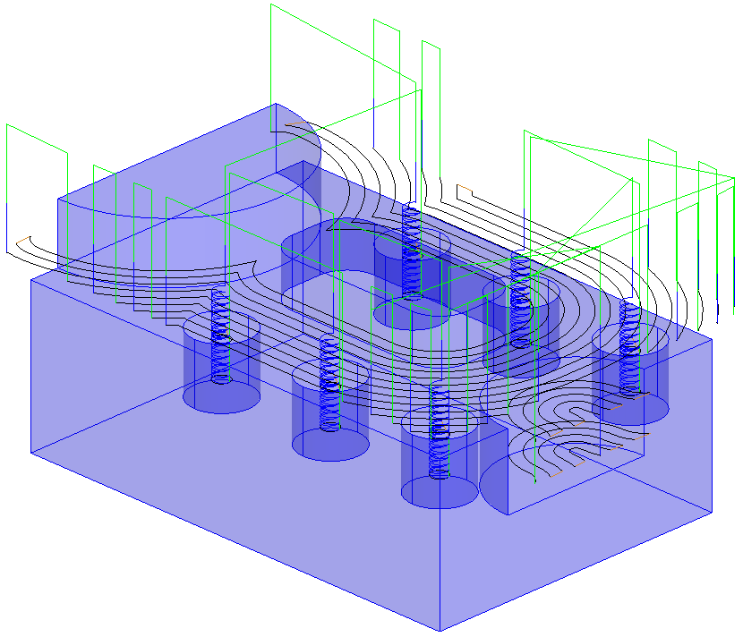

As Flat surface support is turned off, FeatureMILL3D has ignored all of the flat surfaces and cut only at the specified Z levels (every 12mm down from the top of the stock).

- Run a 3D Simulation.

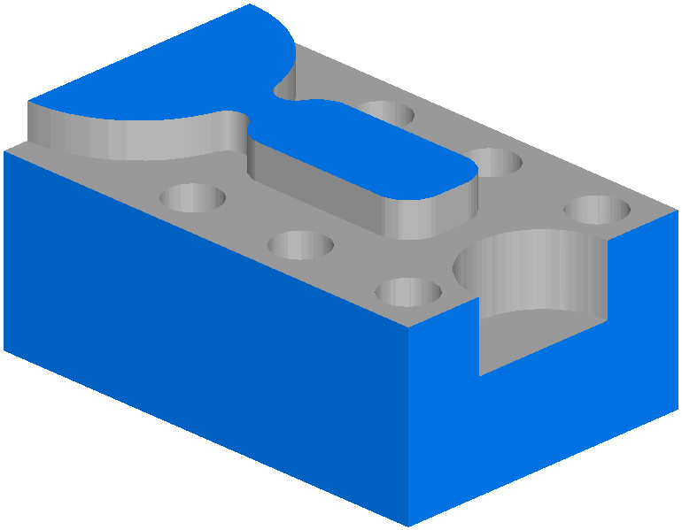
It can be seen that a lot of stock remains in the areas indicated. This could cause problems for subsequent operations. We will now look at the alternatives.

- Edit the feature.
- Click on rough 1 in the tree view.
- Select the Milling tab.
- Change Flat level support to Level.
- Click Apply and then OK.
- Run a Centerline simulation.
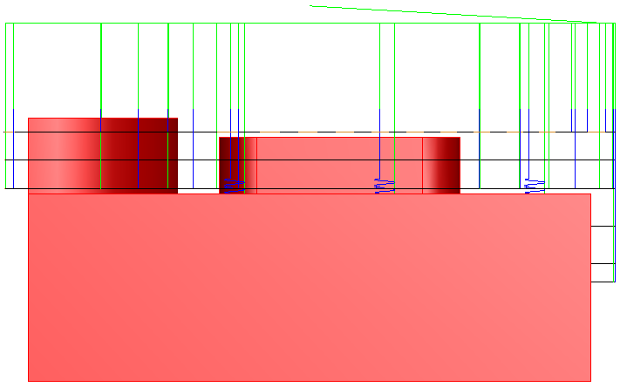
- Select a view from the Left.

Three extra roughing levels have been added. These are offset from the flat surfaces by the Finish Allowance plus the Rough Tolerance. The levels extend all the way to the edge of the block thus increasing the machining time. If a part has many flats the machining time may become very long.

- Select an Isometric view.
- Run a 3D Simulation to see how the flat levels are cleared all the way to the edge of the stock.

We will now look at the most efficient way of machining the flat areas on the part.

- Edit the feature.
- Click on rough 1 in the tree view.
- Select the Milling tab.
- Change Flat level support to Area.
- Click Apply and then OK.
- Run a Centerline simulation.
- Select a view from the Left.

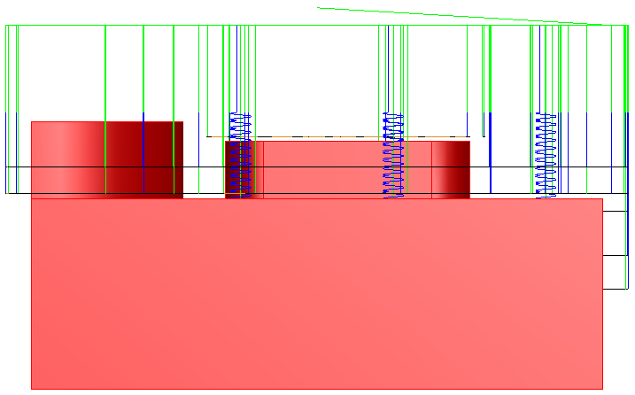

Note how the flat area clearance now only extends to the edge of each flat area. This eliminates unnecessary tool moves and will result in a shorter, more efficient toolpath.

- Select an Isometric view.
- Run a 3D Simulation to see how the flat levels are cleared only in the required areas.

